|  |  |  |  |  |  |  |  |  |
| --- | --- | --- | --- | --- | --- | --- | --- | --- |
| **MAD Project Evaluation 1 – Regular Intake 2022** | | | | | | | | |
| **Team Name:** | Wiz_Kidz | |  |  | **Batch:** | Batch 2.2 | | |
| Student ID | Student Name | Consistency (Out of 2) | Appropriateness and Professionalism (Out of 3) | Usage of resource manager (Out of 4) | Out of box design ideas (Out of 3) | Report (Out of 8) | Total (Out of 20) | Comments |
| IT21031120 | Serasinghe S.M.V.M |  |  |  |  |  |  |  |
| IT20600952 | Sandaruwan K.A. K |  |  |  |  |  |  |
| IT21023200 | Perera K.H |  |  |  |  |  |  |
| IT21045912 | Athukorala K.A.D.P. S |  |  |  |  |  |  |
|  |  |  |  |  |  |  |  |

Git Repository Link:

(If already created)

----------------------------------------------------------------------------------------------------------For Evaluators use only---------------------------------------------------------------------------------------------

Evaluator’s name:

Others:

**Introduction**

**System UI Overview**

**Individual Contribution**

**Athukorala K.A.D.P.S – IT21045912 – Movie Management**

* Add Movies
* Update Movie Details
* View Movie Details
* Delete Movie Details
* Search Movies
* Side Navigation Bar

**Serasinghe S.M.V.M – IT21031120 – Film Hall Management**

* Login Page
* User Profile
* Edit User Profile
* View Film Hall
* Select Film Hall
* Film Hall Detail Page
* Add Film Hall

**Sandaruwan K.A.K – IT20600952 – Ticket Booking Management**

* Ticket Booking
* Booking Details
* My Bookings
* Edit Bookings

**Perera K.H – IT21023200 – Payment Management**

* Enter Card Details
* Display Payment Details
* Update Card Details
* Payment Success Page
* Payment Summery Page

**Athukorala K.A.D.P.S – IT21045912 - Resources**

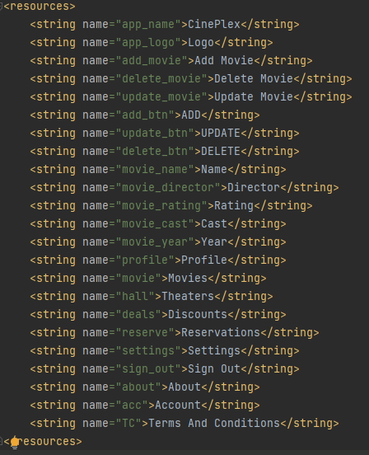**

**UI & Wireframes**

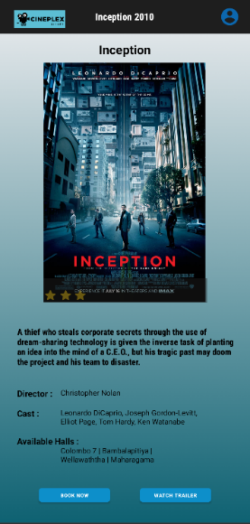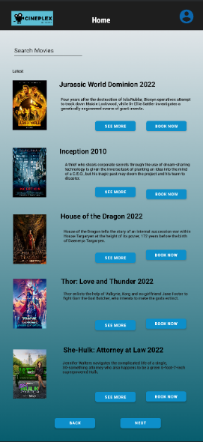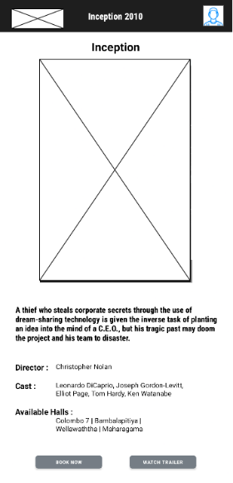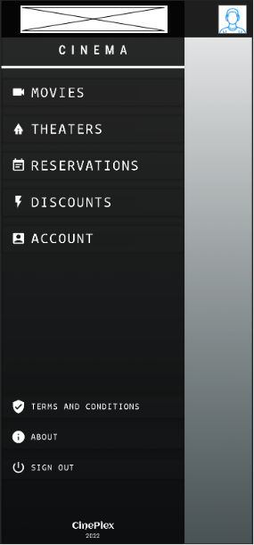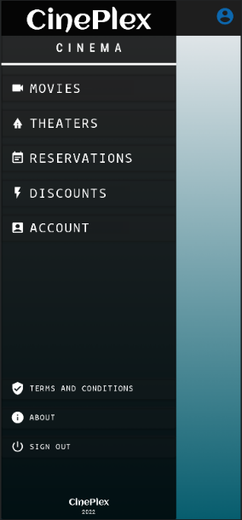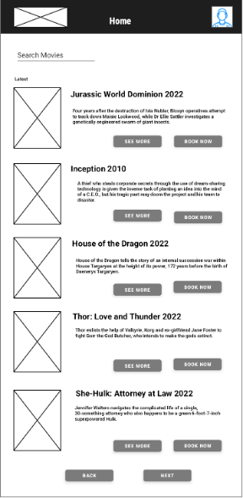

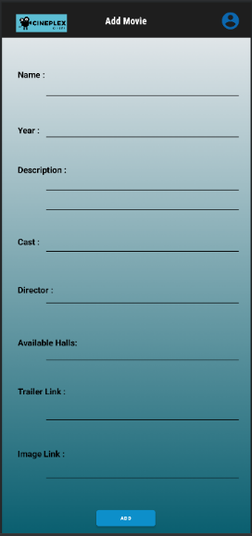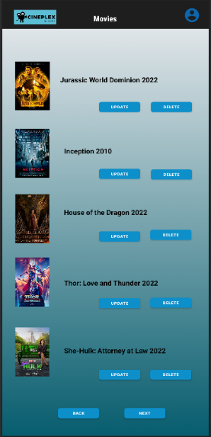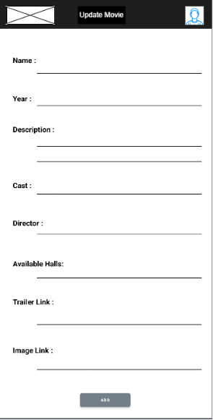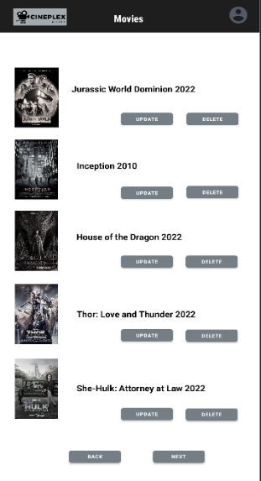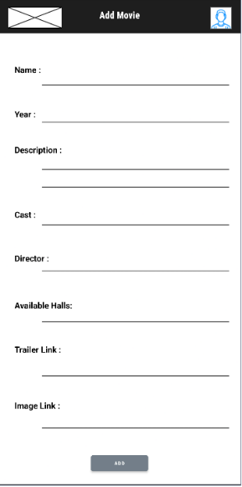

**CRUD Operations & Other Functions**

**Serasinghe S.M.V.M – IT21031120 – Film Hall Management**

**Resources**

**UI & Wireframes**

**CRUD Operations & Other Functions**

**Sandaruwan K.A.K – IT20600952 – Ticket Booking Management**

**Resources**

**UI & Wireframes**

**CRUD Operations & Other Functions**

**Perera K.H – IT21023200 – Payment Management**

**Resources**

**UI & Wireframes**

**CRUD Operations & Other Functions**